**Project Preliminary Report on**

**“SMART WHEELCHAIR FOR PARALYZED”**

***Presented by***

**KNR18EE024. JASIRA T P**

**KNR18EE034. NAYANA RAMESHAN**

**KNR18EE046. SHRAVAN SREEDEEP**

**KNR18EE048. SOORYA P**

***under the guidance of***

**Dr. C SREEKUMAR**



**DEPARTMENT OF ELECTRICAL & ELECTRONICS ENGINEERING**

**GOVT. COLLEGE OF ENGINEERING KANNUR- 670563**

**January 2022**

**ABSTRACT**

Paralyzed stroke patients are unable to normally communicate with their environment. For these patients, the only part of their body that is under their control, in terms of muscular movement, is their eyeballs.

The biggest problem that paralyzed patients face is leading their own life without others support. This include basic day to day operations like switching on basic devices like fan, bulb etc.

An automated working prototype of a smart wheel chair working with a home automation system that can be controlled by eye tracking is implemented in this work. The prototype is designed for the paralysed people with only motor functions for eye movement. This method takes care of surrounding obstructions and decisions are taken accordingly.

**CONTENTS**

|  |  |  |
| --- | --- | --- |
| **Title Page** |  | **i** |
| **Abstract** |  | **ii** |
| **Contents** |  | **iii** |
| **List of Figures** |  | **iv** |
| **CHAPTER 1** | **INTRODUCTION** | **1** |
| **CHAPTER 2** | **LITERATURE REVIEW** | **2** |
| **CHAPTER 3** | **SMART WHEEL CHAIR** | **4** |
| **CHAPTER 4** | **SIMULATION AND RESULTS** | **6** |
|  | 4.1 SIMULATION OF SMART WHEELCHAIR | 6 |
|  | 4.2 SYSTEM ALGORITHM | 6 |
|  | 4.2.1 Face detection and Eye detection | 6 |
|  | 4.2.2 BGR to Gray conversion | 7 |
|  | 4.2.3 Features detection and Blurring image | 7 |
|  | 4.2.4 Edge detection | 7 |
|  | 4.2.5 Eye Tracking | 7 |
|  | 4.3 SIMULATION RESULTS | 7 |
|  | 4.3.1 Eye Tracking Model | 8 |
|  | 4.3.2 Wheelchair model simulation results | 9 |
| **CHAPTER 5** | **CONCLUSIONS** | **12** |
| **REFERENCES** |  | **13** |

**LIST OF FIGURES**

|  |  |  |
| --- | --- | --- |
| No | Title | Page No |
| 3.1 | Diagram of Smart Wheelchair | 4 |
| 4.1 | Simulation Model of Smart Wheelchair | 6 |
| 4.2 | Coordinates system with respective eye position | 7 |
| 4.3 | Eye Tracking Results | 8 |
| 4.4 | When Eye pupil are centred. | 9 |
| 4.5 | When Eye pupil are to the left. | 9 |
| 4.6 | When Eye pupil are to the right. | 10 |
| 4.7 | When Eye pupil are down. | 10 |
| 4.8 | When Eye pupil are up position. | 11 |

**CHAPTER 1**

**INTRODUCTION**

The Wheelchair is dependent system used by elderly and physical disable persons. Here introducing the design implementation models of totally independent Eye control electric wheelchair. For a totally paralyzed person it is very difficult to use controller type of electric wheel chair. Here the Eye control system provides the independence to make their life easy and more convenient. And also they save the huge amount of energy or external man power.

Camera captured the image in real time and analysis the image as input to set the commands for interface the motor driver IC through sending the commands to GPIO pins. The motor driver circuit is used to perform the different operation such as left, right, forward and stop. For the advance level of Image Processing open computer vision (OpenCV) library is used for Face and Eye detection. Google’s MediaPipe library is used to find out accurate pupil location detection and tracking of that.

An Eye tracking technique, which capture the image and detects the presents of human face. After detecting the face, it detects area of the eye location on the face detected image, and performs several operation of basic image processing like colour image to grey conversion, filtering, threshold, pattern matching, noise reduction and circle detection on it.

The Raspberry pi board is used to perform the control of the complete system operation. Digital Image processing based output signal sent to the Raspberry pi board. The Raspberry pi acquired the data and analyse it. Raspberry pi send the control signal to motor driving circuit based on the location of eye pupil. In a Wheelchair two individual motors are embedded on each wheel. The Ultrasonic sensor is also mounted on the wheelchair for detection of any static or mobile obstacle. If sensor gets the obstacle very close to the wheelchair, it will indicate to the raspberry pi and raspberry sends the signal to motor driving circuit to stop the motor.

**CHAPTER 2**

**LITERATURE REVIEW**

[1] **Joseph K George, Subhin K B, Arun Jose, Hima T**, “Eye Controlled Home-Automation for Disables”, IOSR, 2019

A low cost eye movement based detection device for controlling home appliances has been discussed in this paper. The device is based on the acquisition of eye blinks which is comparatively inexpensive, efficient in terms of linear relationship of the signal over the eye movements that makes it suitable for the application. The device here incorporates activation and deactivation of appliances such as fan, bulb, GSM and alarm etc. The method of eye tracking using camera requires a fully dedicated system with image processing software during the entire working of the unit.

[2] **Tan Kian Hou, Yagasena and Chelladurai,** “Arduino based voice controlled wheelchair”, ICE4CT, 2019

This paper describes the design of a smart, motorized, voice controlled wheelchair using embedded system. Proposed design supports voice activation system for physically differently abled persons incorporating manual operation. This paper represents the “Voice-controlled Wheel chair” for the physically differently abled person where the voice command controls the movements of the wheelchair. The voice command is given through a cellular device having Bluetooth and the command is transferred and converted to string by the BT Voice Control for Arduino and is transferred to the Bluetooth Module SR-04connected to the Arduino board for the control of the Wheelchair.

[3] **Mohammed Hayyan Al Sibai and Sulastri Abdul Manap**, “A Study on Smart Wheelchair Systems”, *International Journal of Engineering Technology and Sciences*, 2015

Smart wheelchair’s purpose is to reduce or eliminate the user's full responsibility on moving the wheelchair. They are also designed for a variety of user types according to their situations and disabilities. One drawback of the Smart wheelchairs is the higher price of them comparing with the manual or the simple electrical powered wheelchairs. This paper reviews recent smart wheelchair systems. Commercialization issues and price estimation are discussed. Clinicians and users’ attitude toward the smart wheelchair is considered. Finally, new future directions for our ongoing research project are discussed.

[4] **Airi Ishizuka, Ayanori Yorozu and Masaki Takahashi**, “Driving Control of a Powered Wheelchair Considering Uncertainty of Gaze Input in an Unknown Environment”, *MDPI*, 2018

This paper describes the motion control system for a powered wheelchair using eye gaze in an unknown environment. It is based on gaze detection and environment recognition that are integrated by the fuzzy set theory in real time. In the fuzzy set theory, we achieve the movement to the passage which a passenger gazes towards among some passages by integrating the information of some passages and gaze. The effectiveness of the proposed method was verified by performing an experimenting involving an actual HCI in a real operating environment. In future endeavours, the authors intend to perform involving various age groups and examine whether there exists a difference in gaze movement depending on the subject’s age. In addition, they intend to verify the system’s effectiveness in dynamic real-life environments involving other people moving in the scene.

[5] **Mohammad A.Eid, Nikolas Giakoumidis and Abdulmotaleb EL Saddik**, “A Novel Eye-Gaze-Controlled Wheelchair System for Navigating Unknown Environments: Case Study with a Person with ALS”, *IEEE Access*, 2016

This paper presented an eye-gaze control system for people with motor disability. Some of the features include the design of an eye-gaze virtual keyboard for writing text, an automation system to control the ambient environment (such as lights, AC, etc.) and an interaction paradigm to connect a person with motor disability to social media and entertainment systems. We would also like to investigate collaborative control (multiple persons with disability or the user with disability and the caregiver). Further development in this system will pay particular attention to the cost factor.

**CHAPTER 3**

**SMART WHEEL CHAIR**

This system is totally autonomous system, and all the module will work independent each other. For the basic requirement of the any electronic system is Power supply. In this system there is mandatory to gives the proper power supply to individual components, and the standard power supply should be used for Raspberry pi, camera, sensor, and motors. The Raspberry pi board is brain of wheelchair. In proposed system model the module like monitor, camera, power circuit and Wi-Fi Adapter is directly connected through the Raspberry pi board. And Raspberry pi board is connected to the internet for remote access facilely, In case emergency controlling or monitoring the status of wheelchair, will be carried out by access the raspberry pi board at remote place using web-server (internet).

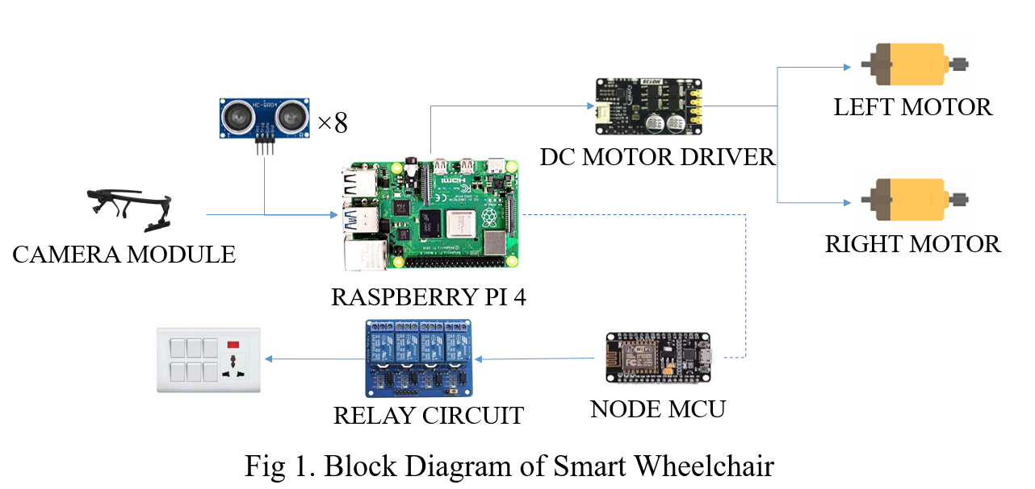

Fig 3.1 Diagram of Smart Wheelchair

For capturing the image a 5 MP web camera is used in our system. The Raspberry gives the commands to the motor driver circuit, which is enable the GPIO pin to perform operation. Such as forward, left, right and stop operation performed based on eye movements. Sensors are also mounted on the head of wheelchair for detecting the obstacles and controlling the wheelchair. Ultrasonic sensor is used for detecting the obstacle or any moving object in front of wheelchair. The sensor is directly connected to the Raspberry pi board, it acquired the data and measuring the distance between wheelchair and obstacle.

This system is comes under real time data acquisition, data processing and controlling system. There is real time video capturing and advance image processing used on it. For using Raspberry pi board, they have its own operating system is known as “Raspbian”, which is Linux based operation system and also compatible with raspberry pi board.

To detect the exact eye pupil location is very challenging. A new image processing technique used for eye pupil center detection and tracking, which works based on open computer vision (OpenCV) library. Most of coding part done with the help of OpenCV library. Google’s MediaPipe library is used to find out accurate pupil location detection and tracking of that. Python language is used for codding, which is user friendly and helpful to resolve the error efficiently.

For home automation system, the raspberry pi connects with the Node MCU when it enters its range. This will enable raspberry pi to control home appliances. Control signals are generated using combination of blink and position of eye balls.

**CHAPTER 4**

**SIMULATIONS AND RESULTS**

**4.1 SIMULATION OF SMART WHEELCHAIR**

The simulation was done using proteus design suite. The model of smart wheelchair is shown in Fig 4.2.

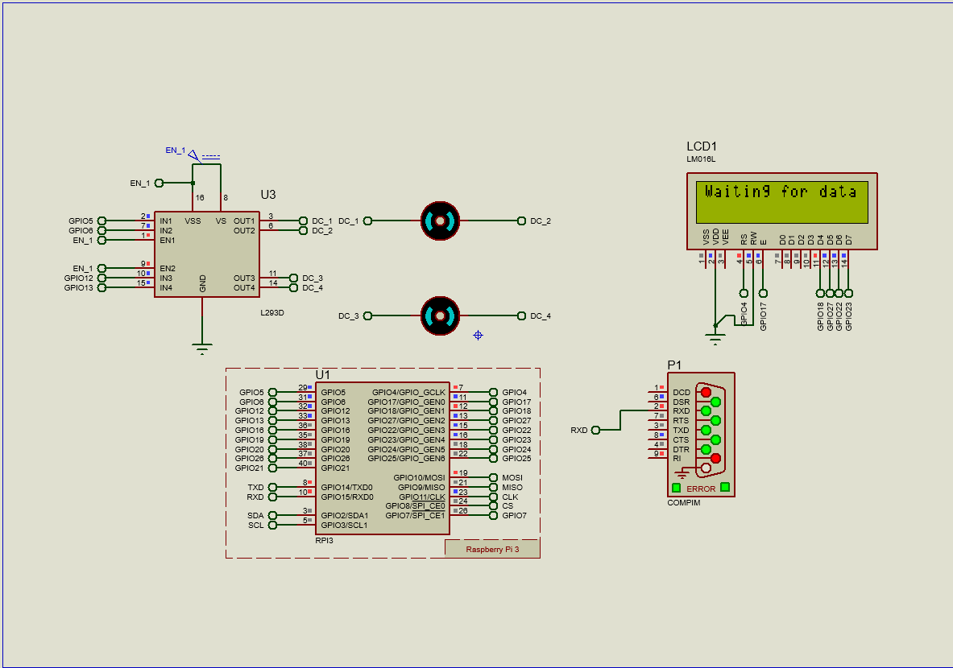

Fig 4.1 Simulation Model of Smart Wheelchair

In simulation, 2 DC motors of 24V is used with motor driver circuit for controlling the motors. The signals from the eye tracking program is transferred to the Raspberry Pi 4 model of proteus design suite. To identify the control signals and LCD monitor is connected to the Raspberry Pi 4.

**4.2 SYSTEM ALGORITHM**

In our system open computer vision (OpenCV) free access library algorithm used for Image processing. The OpenCV library play a very important role, and it gives the knowledge of Image processing. A novel algorithm used for system execution and perform the operation. To find out the pupil center point of the Eye, we followed some steps:

**4.2.1 Face detection and Eye detection**

For the face detection and eye detection the OpenCV library is used directly. A system camera detects the face of user. Once it will detected, system finds the eye location and marks the eye region using Mediapipe library. And system accurately detect both the eyes based on the proper distance of the each other.

**4.2.2 BGR to Gray conversion**

A very next operation of the image color convention to reduce the system delay time. The Image frame size should be low, because the processor cannot processing the image frames in run time condition. So, by using the BGR to GRAY conversion a colored image converted into gray image.

**4.2.3 Features detection and Blurring image**

The Gaussian blur filter is used for blurring the image. Which helps to detect the exact edges of specific area of the cropped image. Features is nothing but it found some special pattern on image which is unique, based on it will make a pattern.

**4.2.4 Edge detection**

A canny Edge detection and corner edge detection algorithm is applied for determine the soft edges of the image. To set the proper threshold value it will allowed easy to recognize rectangles or circle presented in Image.

**4.2.5 Eye Tracking**

To track the Eye movements we use projection function algorithm was used, where the coordinates system points the eye centre point location. In Fig 4.1 indicates the eye pupil location with respective coordinate’s system graph.



Fig 4.2 Coordinates system with respective eye position

**4.3 SIMULATION RESULTS**

The results of the smart wheelchair and eye tracking models are provided below.

**4.3.1 Eye Tracking Model**

Fig 4.3 Eye Tracking Results.

The result for eye tracking program is shown below.

|  |  |
| --- | --- |
| a. Center | b. Closed |
| c. Left | d. Right |

**4.3.2 Wheelchair model simulation results**

The result for smart wheelchair model using proteus design suite is shown below.

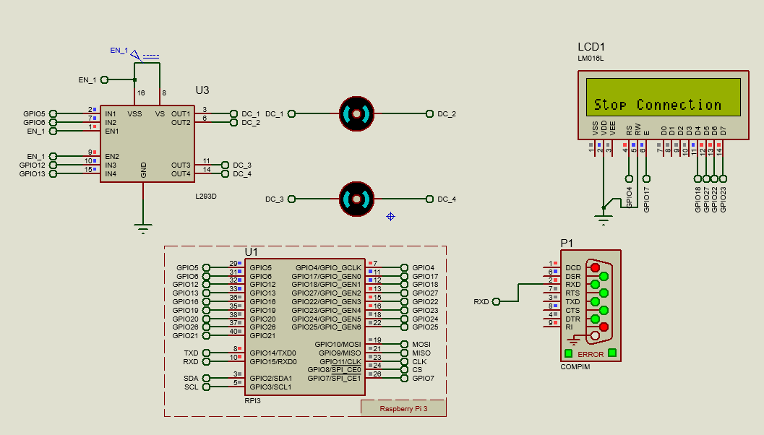

Fig 4.4 When Eye pupil are centred.

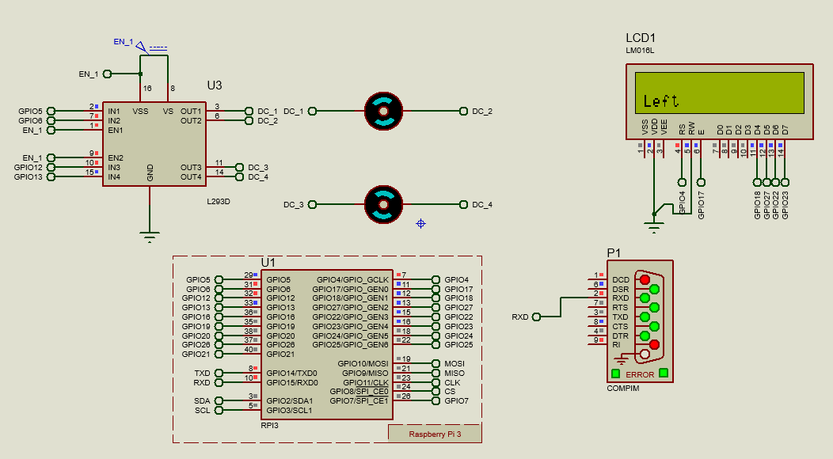

Fig 4.5 When Eye pupil are to the left.

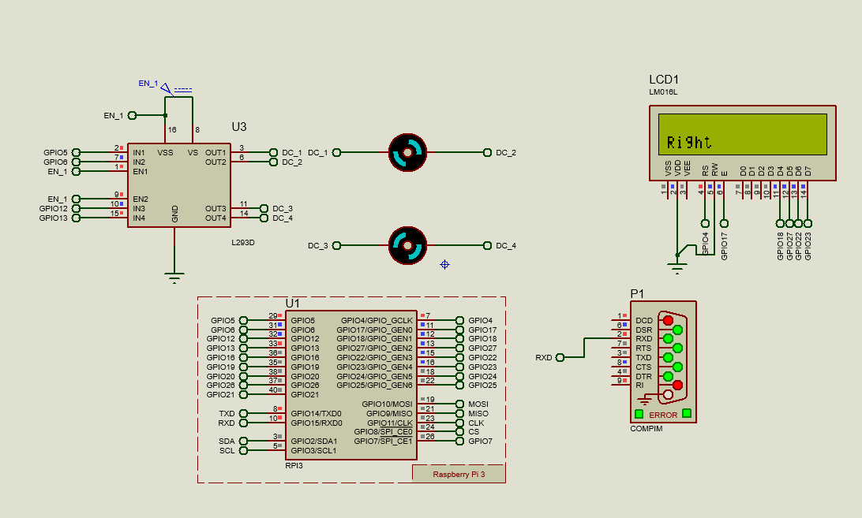

Fig 4.6 When Eye pupil are to the right.

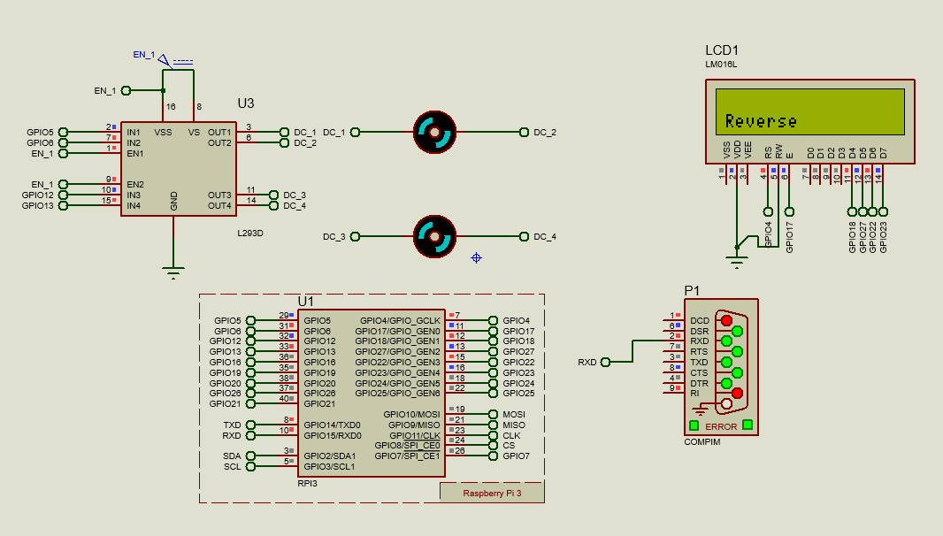

Fig 4.7 When Eye pupil are down.

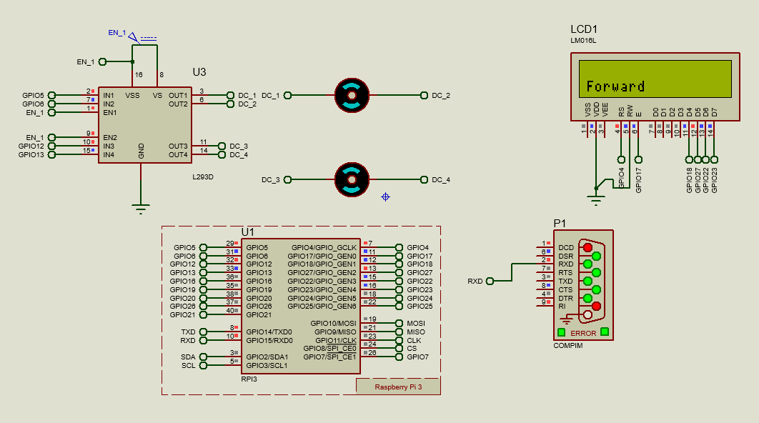

Fig 4.8 When Eye pupil are up position.

**CHAPTER 5**

**CONCLUSION**

Paralyzed stroke patients are unable to normally communicate with their environment. The biggest problem that paralyzed patients face is leading their own lives without the assistance of others. As a solution to this problem, a smart wheel chair working with a home automation system that can be controlled by eye tracking is implemented in this work. The literature review for the proposed model are going on.

The eye tracking model is developed in python language using opencv and mediapipe libraries. Eye tracking technique, captures the image and detects the presence of human face. It detects the location of the eye on the face and conducts basic image processing operations such as color image to grey conversion, filtering, threshold, pattern matching, noise reduction, and circle detection on it after recognizing the face.

For the base controller, Raspberry Pi 4 has been selected. The Raspberry Pi board is utilized to control the entire operation of the system. It receives a signal based on digital image processing. The data was collected and analyzed using the Raspberry Pi. Based on the location of the eye pupil, the Raspberry Pi sends a control signal to the motor driving circuit. Two separate motors are placed in each wheel of a wheelchair. The wheelchair also has an ultrasonic sensor for detecting any stationary or moving obstacles. If the sensor detects an impediment that is quite close to the wheelchair, it will alert the Raspberry Pi, which will send a signal to the motor driving circuit to turn off the motor.

**REFERENCE**

1. **Ahmad F. Klaib1, Nawaf . Alsrehin1, Wasen Y. Melhem, Haneen . Bashtawi, Aws A. Magableh**. “Eye Tracking Algorithms, Techniques, Tools, and Applications with an Emphasis on Machine Learning and Internet of Things Technologies”, September 2020
2. **Mohammed Saifuddin Munna, Juliana Shetara, Shantanu Bhattacharjee, Md. Zahed Hossain Bhuiyan**, “Design & Implementation of a Mind Controlled Home Automation System”, January 2017
3. **Pramodini A. Punde, Dr. Mukti E. Jadhav, Dr. Ramesh R. Manza**, “A study of Eye Tracking Technology and its applications”, *IEEE* 2017
4. **Tan Kian Hou, Yagasena and Chelladurai**“Arduino based voice controlled wheelchair”, 2020
5. **Mohammed Hayyan Al Sibai, Sulastri Abdhul Manap**, “A Study on Smart Wheelchair Systems”, *Research Gate* Dec 2015
6. **Deepak Kumar, Reetu Malhotra, S R Sharma**, “Design & Construction of a Smart Wheelchair”, *Science Direct* 2019
7. **Georges Boustany, Alaa El Deen Itani, Rayan Youssef, Omar Chami, Ziad O. Abu-Faraj**, “Design and Development of Rehabilitive Eye-Tracking Based Home Automation System”, *IEEE* 2016
8. **Joseph K George, Subin K B, Arun Jose, Hima T**, “Eye Controlled Home-Automation For Disables”, *IOSR-JEEE* 2017
9. **Deepak Kumar Lodhi, Prakshi Vats, Addala Varun, Prashant Solanki, Ritakshi Gupta1, Manoj Kumar Pandey, Rajat Butola**, “Smart Electronic Wheelchair Using Arduino and Bluetooth Module”, *IJCSMC* May 2016
10. **Airi Ishizuka, Ayanori Yorozu and Masaki Takahashi**, “Driving Control of a Powered Wheelchair Considering Uncertainty of Gaze Input in an Unknown Environment”, *MDPI*, 2018
11. **Mohammed Hayyan Al Sibai and Sulastri Abdul Manap**, “A Study on Smart Wheelchair Systems”, *International Journal of Engineering Technology and Sciences*, 2015
12. **Mohammad A.Eid, Nikolas Giakoumidis and Abdulmotaleb EL Saddik**, “A Novel Eye-Gaze-Controlled Wheelchair System for Navigating Unknown Environments: Case Study with a Person with ALS”, *IEEE Access*, 2016